

SCHOOL OF ELECTRICAL AND ELECTRONIC ENGINEERING

**Bachelor of Technology (Ord) Networking Technologies**

*Module: COMP3001 – Final Report*

**Programme Code: (DT 080 A) 2019/20**

**YEAR 3**

**Project Title:**

**Temperature Monitor and Notification System**

**Student Name Ion Ichim**

**Class Group Group C**

**Collaborator(s): John Swift**

**Project Supervisor: Dr. Yuri Panarin**

**Date Issued 27/01/2020**

**Word Count 3098**

# THE DECLARATION PAGE

**DECLARATION**

I hereby certify that the material, which is submitted in this final report, is entirely my own work and has not been submitted for any academic assessment other than as part fulfilment of the assessment procedures for the programme,Bachelor of Technology (Ord) Networking Technologies(DT 080A).



Signature of student:

Date: 24/02/2020

TABLE OF CONTENTS

THE DECLARATION PAGE 2

ABSTRACT 4

BACKGROUND OF THE PROJECT 5

THE PROPOSED SOLUTION 7

EVALUATION OF THE RESULTS and TROUBLESHOOTING 12

SUMMARY 16

IDEAS FOR FUTURE REPLICATION AND/OR RESEARCH THE PROJECT TOPIC 17

CONCLUSION 17

REFERENCES 18

APPENDICES 20

The Main Flowchart of TMNS Appendix A 20

The SMS Routine Appendix B 21

The Blynk Routine Appendix C 22

The Table of Equipment and Prices Appendix D 23

The code on Arduino UNO Appendix E 24

The code on Arduino ESP32 Appendix F 27

TABLE OF FIGURES

[**Figure 1 The process of how Fuel poverty arises [27] 4**](https://tudublin-my.sharepoint.com/personal/c17719611_mytudublin_ie/Documents/Project%20Ion%20Ichim.docx#_Toc33275483)

**Figure 2: Population unable to keep adequately warm by poverty status (%), [5] 5**

**Figure 3 The Diagram of Initial Proposal [6] 6**

[**Figure 4 The Arduino Uno Board [7] 7**](https://tudublin-my.sharepoint.com/personal/c17719611_mytudublin_ie/Documents/Project%20Ion%20Ichim.docx#_Toc33275486)

[**Figure 5 The Grove Based Shield v2.0 [8] 7**](https://tudublin-my.sharepoint.com/personal/c17719611_mytudublin_ie/Documents/Project%20Ion%20Ichim.docx#_Toc33275487)

[**Figure 6 The ESP 32 Board [9] 7**](https://tudublin-my.sharepoint.com/personal/c17719611_mytudublin_ie/Documents/Project%20Ion%20Ichim.docx#_Toc33275488)

[**Figure 7 The Grove LCD RGB Backlight [10] 7**](https://tudublin-my.sharepoint.com/personal/c17719611_mytudublin_ie/Documents/Project%20Ion%20Ichim.docx#_Toc33275489)

[**Figure 8 The Grove Temperature Sensor [11] 7**](https://tudublin-my.sharepoint.com/personal/c17719611_mytudublin_ie/Documents/Project%20Ion%20Ichim.docx#_Toc33275490)

[**Figure 9 The Grove Relay [12] 8**](https://tudublin-my.sharepoint.com/personal/c17719611_mytudublin_ie/Documents/Project%20Ion%20Ichim.docx#_Toc33275491)

[**Figure 10 The Power Relay [13] 8**](https://tudublin-my.sharepoint.com/personal/c17719611_mytudublin_ie/Documents/Project%20Ion%20Ichim.docx#_Toc33275492)

[**Figure 11 The Grove Buzzer [14] 8**](https://tudublin-my.sharepoint.com/personal/c17719611_mytudublin_ie/Documents/Project%20Ion%20Ichim.docx#_Toc33275493)

[**Figure 12 The Grove Touch Sensor [15] 8**](https://tudublin-my.sharepoint.com/personal/c17719611_mytudublin_ie/Documents/Project%20Ion%20Ichim.docx#_Toc33275494)

[**Figure 13 The Power Supply 5V for Arduino UNO [16] 8**](https://tudublin-my.sharepoint.com/personal/c17719611_mytudublin_ie/Documents/Project%20Ion%20Ichim.docx#_Toc33275495)

[**Figure 14 The Webhooks Service set up to send an SMS [25] 9**](https://tudublin-my.sharepoint.com/personal/c17719611_mytudublin_ie/Documents/Project%20Ion%20Ichim.docx#_Toc33275496)

[**Figure 15 The Blynk App - Button set as a switch (ON/OFF) [26] 9**](https://tudublin-my.sharepoint.com/personal/c17719611_mytudublin_ie/Documents/Project%20Ion%20Ichim.docx#_Toc33275497)

**Figure 16 The sample of Alert "Fire hazard !!" [20] 10**

**Figure 17 The general functions of Proposed Solution [22] 10**

**Figure 18 The Block Diagram of Proposed Solution [23] 11**

[**Figure 19 The Arduino ESP32 Wi-Fi connection 11**](https://tudublin-my.sharepoint.com/personal/c17719611_mytudublin_ie/Documents/Project%20Ion%20Ichim.docx#_Toc33275501)

[**Figure 20 The error of LM35 temperature sensor 12**](https://tudublin-my.sharepoint.com/personal/c17719611_mytudublin_ie/Documents/Project%20Ion%20Ichim.docx#_Toc33275502)

[**Figure 21 The missing IFTT host name 13**](https://tudublin-my.sharepoint.com/personal/c17719611_mytudublin_ie/Documents/Project%20Ion%20Ichim.docx#_Toc33275503)

[**Figure 22 Fixing the issue with connection to (IFTT) 13**](https://tudublin-my.sharepoint.com/personal/c17719611_mytudublin_ie/Documents/Project%20Ion%20Ichim.docx#_Toc33275504)

**Figure 23 The connection to wrong Arduino board 14**

[**Figure 24 The front view of Arduino (TMNS) [33] 14**](https://tudublin-my.sharepoint.com/personal/c17719611_mytudublin_ie/Documents/Project%20Ion%20Ichim.docx#_Toc33275506)

[**Figure 25 The Inside open- view of Arduino (TMNS) [32] 14**](https://tudublin-my.sharepoint.com/personal/c17719611_mytudublin_ie/Documents/Project%20Ion%20Ichim.docx#_Toc33275507)

**Figure 26 The Main Flowchart of TMNS [27] 19**

**Figure 27 The SMS routine flowchart of TMNS [28] 20**

**Figure 28 The Blynk Service flowchart [29] 21**

**Figure 29 The Table of Equipment and Prices 22**

## ABSTRACT

In Ireland a high number of people frequently live in cold, damp and thermally inefficient housing. This can have a detrimental effect on their health both directly and indirectly. Reasons for this include low household income, poor energy efficiency of the home or high fuel prices. In order to minimise this health risk, a solution is needed which can alert a relative or care worker that is both affordable and functional.

The proposed solution, as a proof of concept, is to build and program Arduino based Temperature Monitor and Notification System which will initially have three working modes: the normal operation mode, the fire alarm mode and the low temperature mode, if the average temperature is lower than (20C and/or higher then 57C) the (TMNS) connects via smartphone’s hotspot or Wi-Fi, to the (IFTT) Cloud service and a notification(SMS or/and email) is send to a designated person, which will also allow the recipient to use a Blynk application, to remotely control an oil heater. This solution is affordable and could be easily installed to aid the socially isolated and/or fuel poverty affected home. This system is also quite adaptable, allowing many other Arduino sensors(Smoke or CO detectors) or actuators to be added to provide more utility and versatility to the end user.

## BACKGROUND OF THE PROJECT

In Ireland as birth rates decrease, and life expectancy increases the problem of elderly people living in socially isolated circumstances also increases. “Social isolation is a state in which an individual lacks a sense of social belonging and engagement with others. A person may have a minimal number of social contacts or an absence of contact with other people and society” [1]. Socially isolated elderly people are also vulnerable to fuel poverty. Irish research states that, “Fuel poverty arises as a result of the relationship between household income, energy efficiency of the dwelling and fuel prices” [2] .

Figure 1 The process of how Fuel poverty arises [33]

People living in fuel poverty frequently live in cold, damp and thermally inefficient houses. The World Health Organization's (WHO) standard for warmth says “18C (64F) is suitable for healthy people who are appropriately dressed. For those with respiratory problems or allergies, they recommend a minimum of 16C (60.8C); and for the sick, disabled, very old or very young, a minimum of 20C (68F)” [3].

The Fuel Poverty certainly can have direct or indirect impacts on health. Direct effects of fuel poverty are: “Colder indoor temperatures placing a ‘thermal stress’ on the body, affecting the immune and cardiovascular system. Cold damp houses harbour mould and dust mites which aggravate respiratory and allergic conditions” [2]. The Indirect effects are that “fuel-poor households tend to accumulate debt ultimately leading to disconnection from mainstream fuel and electricity supplies which drives them further into poverty and social exclusion” [2]. Households comprising older people, young children, those with disabilities and/or long-term illness are especially vulnerable.

The Central Statistics Office data published recently in the EU Survey of Income and Living Conditions it finds that “12.3 per cent or 140,000 of Irish children are living in fuel poverty and that in 2018 more than 10 per cent of one-parent households could not afford to heat their home adequately” [4].Another EU SILC indicator quantifies the proportion of the population consistently unable to keep the home adequately warm. Research indicates that “The proportion of the total population experiencing this type of deprivation in 2017 was 213,708 people”, as presented in the Fig.2 [5].

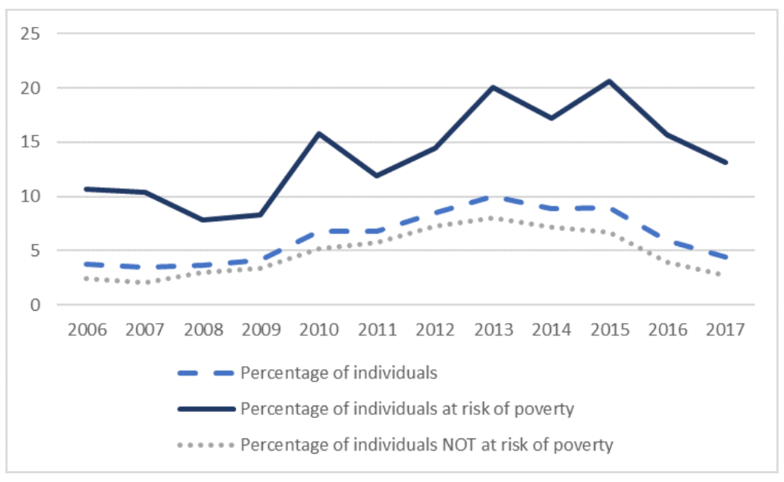

Figure 2: Population unable to keep adequately warm by poverty status (%), [5]

Finding a solution to fuel poverty with microcontrollers, temperature sensors or the Internet of Things (IoT) is out of the scope of this project however a system could be devised to enable relatives or care workers to act quickly enough to come to the aid of people at risk, early intervention being critical in minimising negative health outcomes and the associated costs.

## THE PROPOSED SOLUTION

Technology is seen as a key enabler in efforts to reduce social isolation and loneliness by enabling those affected to better maintain existing social connections or reduce the negative effects of fuel poverty. These technologies range from wearables such as GPS-enabled personal devices to smart and networked home devices and the development of the Internet of Things (IoT) to Artificial Intelligence (AI) and robotics.

All of these technologies have huge potential to change the lives of social isolated people with regard to their safety and wellbeing, but today, the market for these technologies is not mature. In most cases these technologies are too expensive for wide adoption. This system, as a proof of concept, is to build and program Arduino based Temperature Monitor and Notification System (TMNS), that is affordable, suitable for the socially isolated and fuel poverty affected people to use in their own homes, (see Fig.3) the initial proposed solution.

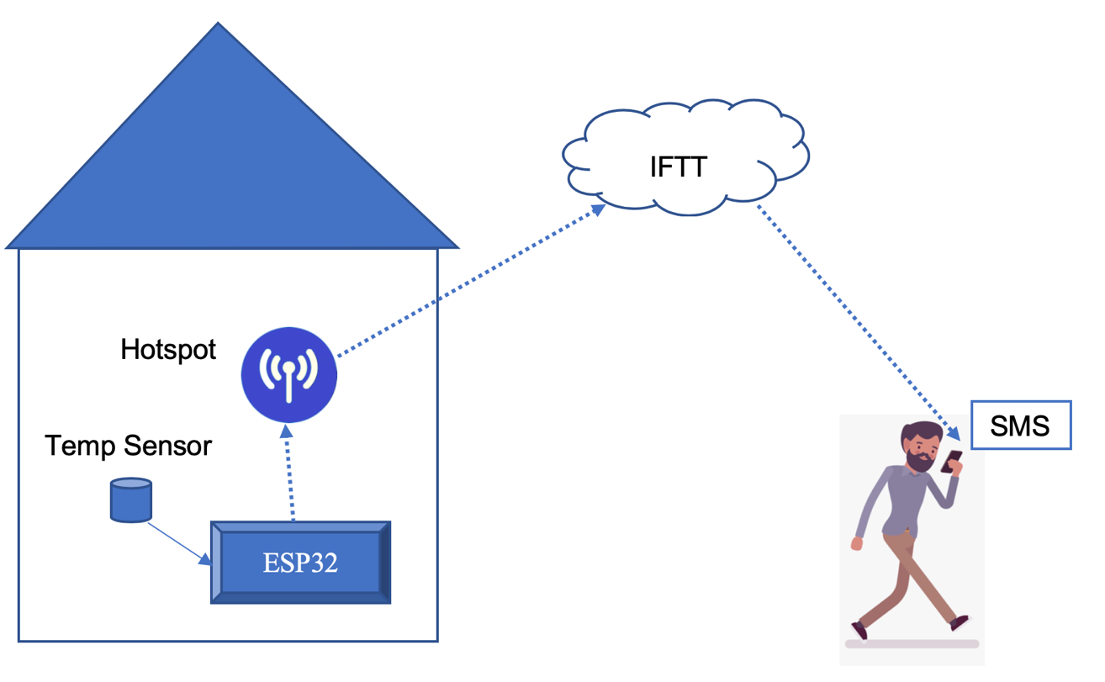

Figure 3 The Diagram of Initial Proposal [6]

**THE IMPLIMENTATION**

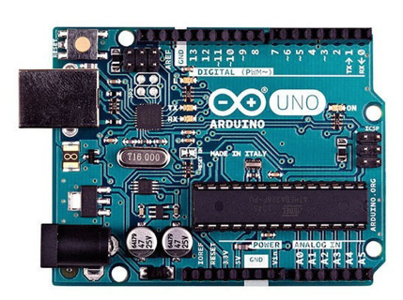For implementation of Arduino Temperature and Notification System (ATNS) the following equipment has been used:

1. ***The Arduino UNO*** - is “a microcontroller board see based on a removable, dual-inline-package (DIP) ATmega328 AVR microcontroller”. Used To support all peripheral sensors and actuators [7].

Figure 4 The Arduino Uno Board [7]

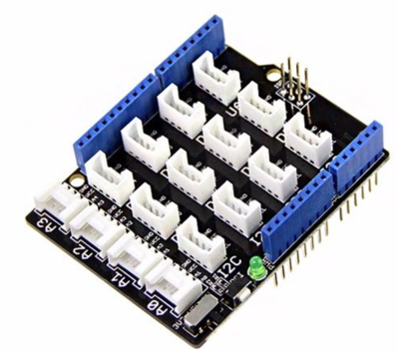

1. ***Grove Base Shield V2.0***-provides a simple way to connect with Arduino boards. “With the 16 on-board Grove Connectors, the connection with over 300 Grove modules is possible” [8].

Figure 5 The Grove Based Shield v2.0 [8]

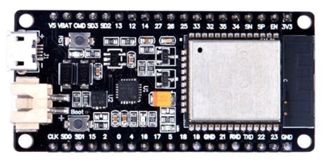

1. **The ESP 32 board** – used to run the Wi-Fi connection to the Cloud, it also has “plenty of analog inputs, multiple extra peripherals, dual core, higher-speed processor” [9].

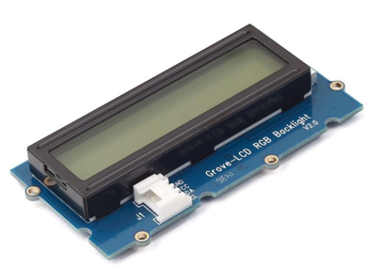

Figure 6 The ESP 32 Board [9]

1. **Grove - LCD RGB Backlight** is “a full-colour backlight 16x2 LCD used for display sensors readings” [10].

Figure 7 The Grove LCD RGB Backlight [10]

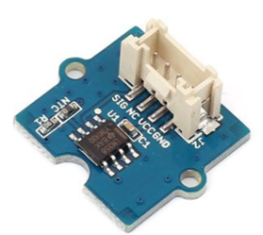

1. **Grove - Temperature Sensor** uses a thermistor to measure ambient temperature. “The operating range is -40 to 125°C, with an accuracy of 1.5°C” [11].

Figure 8 The Grove Temperature Sensor [11]

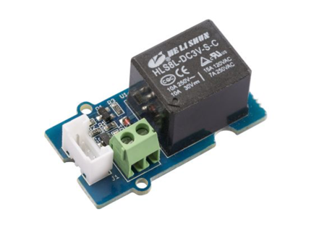

1. **Grove - Relay** used to control the power delivery to ESP32, it “can handle the current up to 5A at 250VAC for long periods of time. The peak voltage capability is 250V at 10A” [12].

Figure 9 The Grove Relay [12]

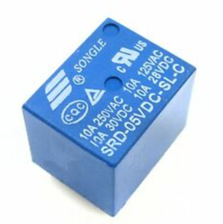

1. **Power Relay SRD-5VDC-SL-C –** used to control power supply to a remote oil heater, “PCB plug-in type power relay. Suitable for domestic appliance, office machine, audio, equipment, automobile, etc” [13].

Figure 10 The Power Relay [13]

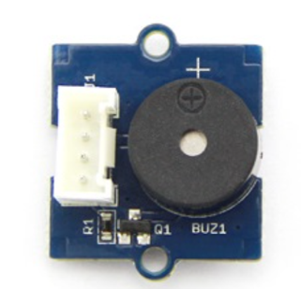

1. **The Grove** **- Buzzer** module has a piezo buzzer as the main component. “The piezo can be connected to digital outputs, and will emit a tone when the output is HIGH” [14]

Figure 11 The Grove Buzzer [14]

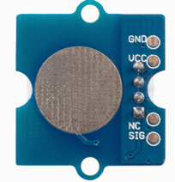

1. **Grove - Touch Sensor** used to turn off the buzzer and reset the device. “It can detect the change in capacitance when a finger is nearby” [15].

Figure 12 The Grove Touch Sensor[15]

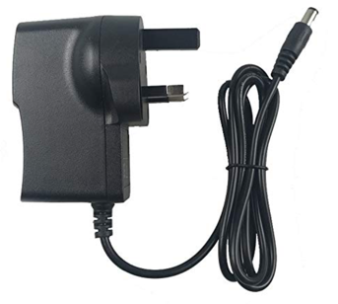

1. **Power Supply – 5V-DC** – used to supply 5V to Arduino UNO board, “Input: 100-240V AC,50-60Hz/ Output: 5V 3A max” [16]

Figure 13 The Power Supply 5V for Arduino UNO[16]

Based on the initial proposed concept, in which the temperature will be sampled inside the house, an average calculated for a period of time and if the average falls under the threshold value of 20 C, based on the WHO standards for warm home which states “a minimum (LOW) temperature threshold, of 20C (68F) “, the Arduino ESP 32 board, will make a Wi-Fi connection(via hotspot or router) with the Cloud in order to send the notification. [3].

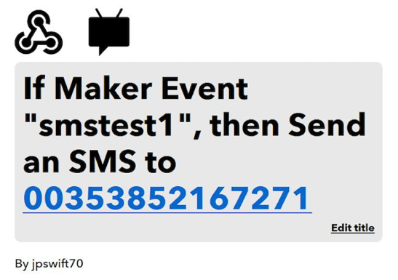For reliable communication between ESP32 board and the relative person, the Cloud service If This Then That (IFTT) has been chosen. IFTT is a “free web-based service that is used to create chains of simple conditional statements, called applets” [17].

The IFTT applet is integrated with Webhooks which is a “service that works with any device or app and can make or receive a web request” (see Fig.14), which could be used as a trigger in order to send an SMS or email, to relative/care worker regarding the drop of temperature inside the house [18] .

Figure 14 The Webhooks Service set up to send an SMS[31]

If the average temperature is lower than 20C (68F) the Arduino ESP32 connects to the Cloud (IFTT and Webhooks) by sending an URL Get Request

(*ex: "https://maker.ifttt.com/trigger/smstest1/with/key/y-MWnviJjvzclIFQGDCQp”),* when the Maker service receives a HTML Get request with value” smstest*1****”***, it will send an SMS to the number of a relatives or care worker, see the SMS flowchart routine (Appendix B, Fig.20). The same set up it used, in case if the notification method is an email.

The designated party receiving the message regarding the drop of the temperature in the house, has an option to use Blynk app which is a “Platform with IOS and Android apps to control Arduino over the Internet”, in order to connect remotely the oil heater [19].

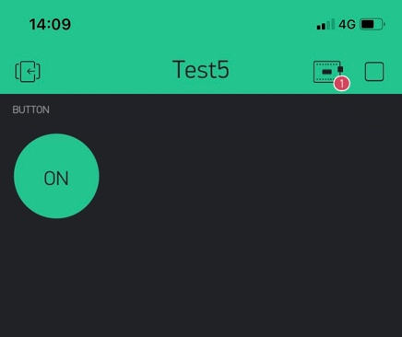When the person presses “ON button” see Fig.15 on his/her smartphone, the Blynk service connects to Arduino ESP32, which will connect the contacts on Grove Relay and then the oil heater will turn on (see Appendix C, Fig.20)

The idea to integrate a Fire Alarm came on, as the project progressed, another temperature trigger of 57°C degrees has been set “The most common fixed temperature point for electrically connected heat detectors is 57°C (136.4°F)” [20].

Figure 15 The Blynk App - Button set as a switch (ON/OFF*)* [32]

If the average temperature is higher than 57C degrees, the TMNS will Display on Grove - LCD RGB Backlight see Fig.16 (the temperature shown 24.41C is just for purpose of testing), the Alert Message *“Fire Hazard”*, flashing from white-to-red colours and the Buzzer will trigger an Alarm Sound,(the connection to IFTT Cloud and notification process is exactly as in case of Low temperature mode, described above.

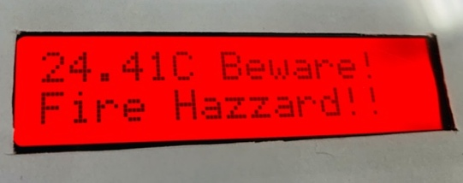

Figure 16 The sample of Alert "Fire hazard !!"[21]

Note : For fire safety and economic reasons the (TMNS) will be connected to the oil heater “The oil retains heat very well and keeps the radiator warm for hours at a time, using less energy to do so than it would to keep air as hot for the same period” [22].

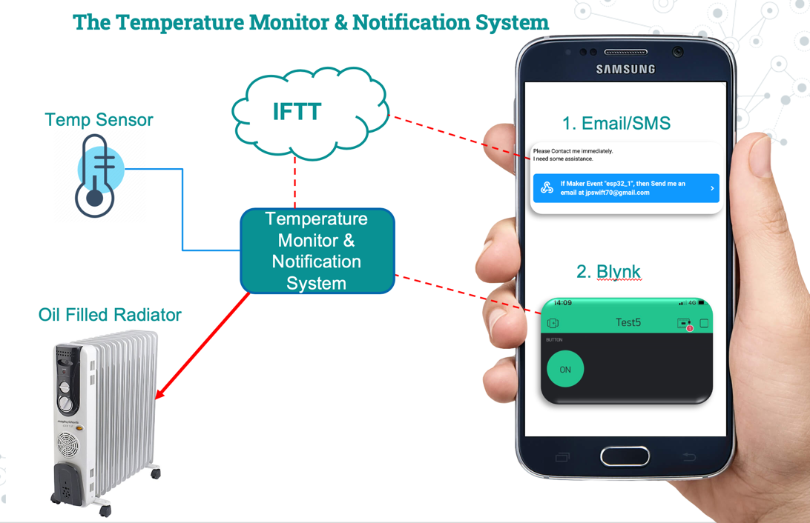

Figure 17 The general functions of Proposed Solution [23]

The Block Diagram of Arduino Temperature Monitor and Notification System, that highlights the main components and the operational flow between them, Fig.18

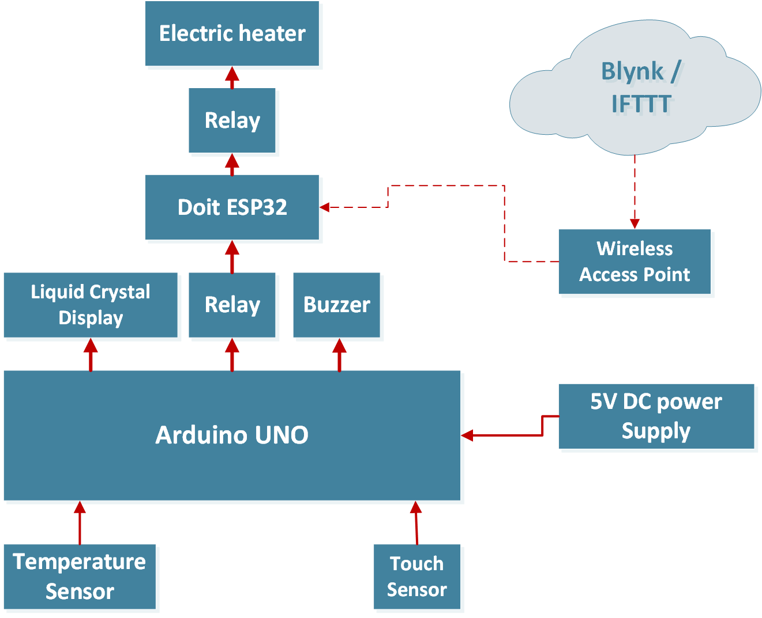

Figure 18 The Block Diagram of Proposed Solution[24]

The overall functions and modes of TMNS are shown on Main Flowchart (see Appendix A, Fig.19).

## EVALUATION OF THE RESULTS and TROUBLESHOOTING

Taking into consideration that “ESP32 can interface with other systems to provide Wi-Fi and Bluetooth functionality through its SPI / SDIO”, the implementation of this project began with Wi-Fi connection of ESP32 board to wireless access point (hotspot of a smartphone) by using the Arduino IDE Code free example, including the Arduino Wi-Fi Libraries “*WiFi.h and WiFiClientSecure.h*” replacing the SSID and Password of access point(hotspot of a smartphone) [25].

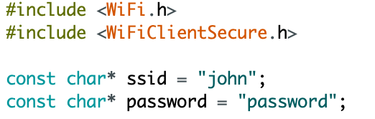

Figure 19 The Arduino ESP32 Wi-Fi connection

After a successful Wi-Fi connection of ESP32 board to access point, the implementation of temperature monitoring began with connection of “LM35 Temperature sensorthat provides temperature range (-55 to150 C)”, to ESP32 [26].

After uploading the code to ESP32 and during testing it was found that the system while initially working as expected would consistently give a temperature reading of 329.92ºC immediately after triggering an email or SMS alert (see Fig.20).

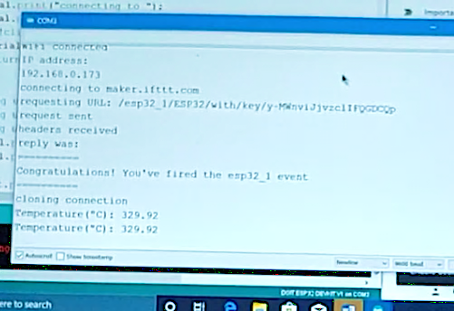

ESP32

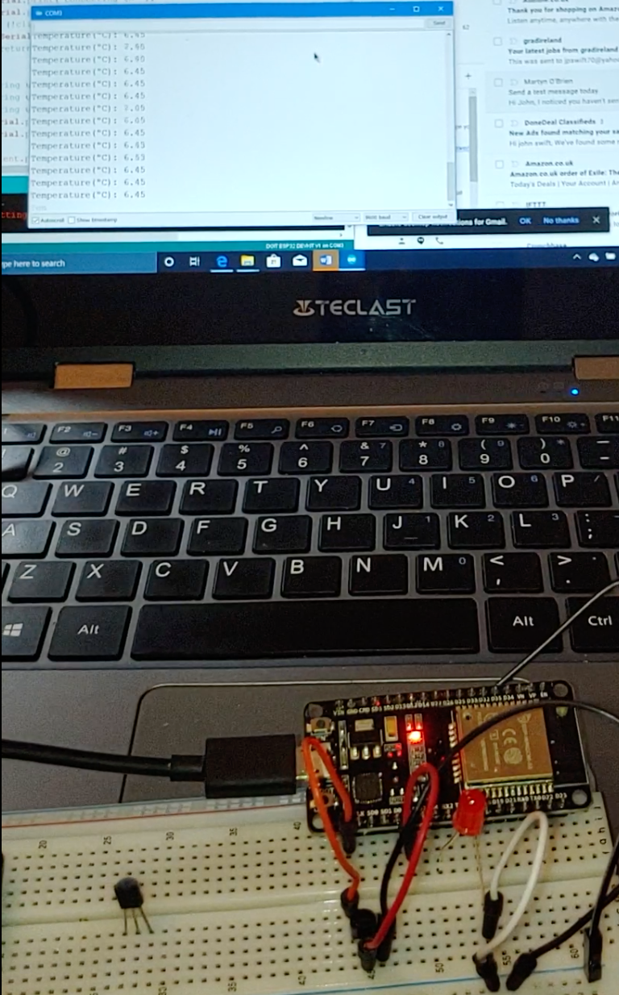

Error - High Temperature

LM35 Temp sensor

Figure 20 The error of LM35 temperature sensor

After many unsuccessful attempts to mitigate this error, the decision has been made, to use the Arduino UNO board Fig.4 with Grove Base Shield V2.0on top(see Fig.5) and Grove Temperature Sensor (see Fig.8), in order to monitor the temperature and resolve the previous issues with LM35 sensor. After uploading the code to Arduino UNO board and checking the sampling of Grove temperature sensor, the consistent average temperature readings had been achieved throughout each phase of operation.

Taking into consideration, that the error has been mitigated, the Arduino UNO board will be used to monitor the temperature inside the house and ESP32 board will be activated by the UNO using a Grove – Relay (see Fig.9) the moment that the temperature has reached a threshold value, and powered for 5 minutes from the UNO allowing connection to be made to the IFTT cloud service. This in turn will trigger the notification process. Using the Grove Base Shield V2.0, it’s east to connect different modules, one of which is the Grove - LCD RGB Backlight (see Fig.7) used here to display the operating state of the device.

As described above, if the average temperature inside the house is lower than 20C (68F) the Arduino ESP32 connects to the Cloud (IFTT and Webhooks) by sending a HTML GET Request, and when the Maker service receives this request with value” **smstest*1”***, it will prompt an SMS to the relative or care worker. One issue discovered in the process of connection with (IFTT) Cloud Service resulted in the notification not being received. Troubleshooting the source of this problem, the following has been discovered.

In the code, see (Appendix F p.28), where GET Request is concatenated with *URL* that specify the trigger value, the IFTT host (***https://maker.ifttt.com/trigger***) hasn’t been specified, as shown below:

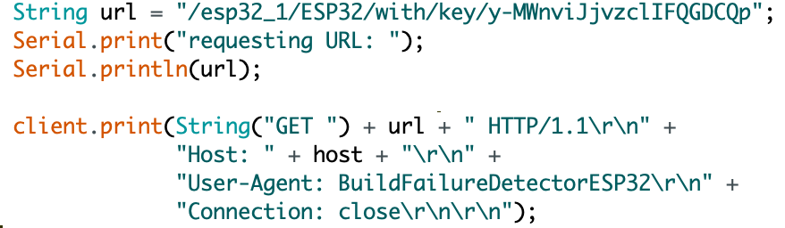

IFTT host name missing !

Figure 21 The missing IFTT host name

To fix this issue, the full host namefor (IFTT) services has been added, see Fig.22 below: *"https://maker.ifttt.com/trigger/smstest1/with/key/y-MWnviJjvzclIFQGDCQp*

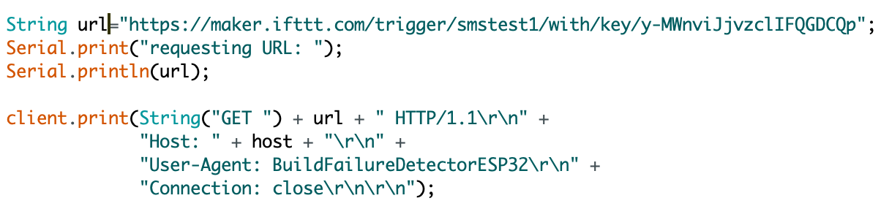

IFTT host name added

Figure 22 Fixing the issue with connection to (IFTT)

After fixing the issue, the connection with IFTT Cloud service has been fixed and notifications received on the specified phone number or email.

Working on implementing of automation by using the Blynk service, as described (see Fig. 15) where a button on Blynk app is set as a switch to turn on the oil heater, after a notification has been received regarding drop of temperature inside the house.

Another issue took place, when switching (on/off) the button on Blynk app, more exactly the lack of connection with ESP 32 board. In order to fix this issue, the logical approach has been followed, by checking the connection to the Arduino board, discovering that the board chosen is wrong “**ESP8266 Module”** see Fig.23 below.

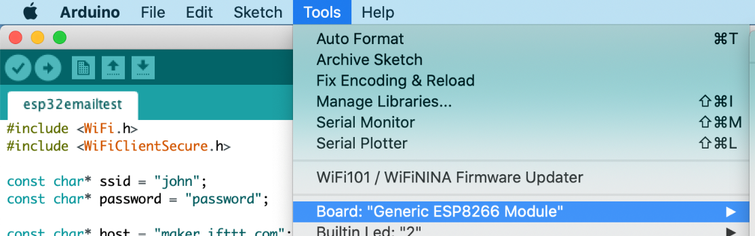

Wrong Arduino Board

Figure 23 The connection to wrong Arduino board

In order to fix this problem, the correct board has been chosen which is: DOIT ESP32 DEVKIT and the Blynk connection to ESP32 board has been established successfully, by turning on/off the contacts on Grove Relay, that is connected to the oil heater (see Appendix C, Fig.20)

After troubleshooting process and fixing all three issues the Temperature Monitor and Notification System (TMNS), has been integrated in a special box see Fig. 23 - 24 below:

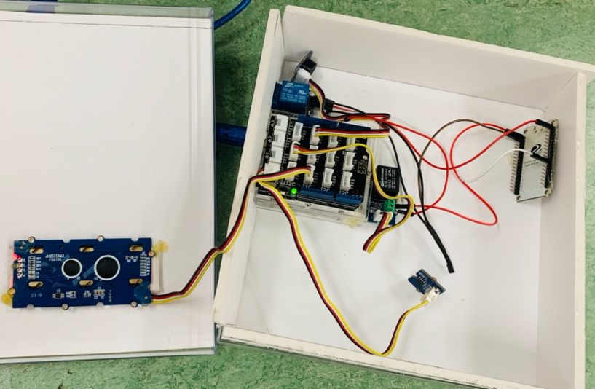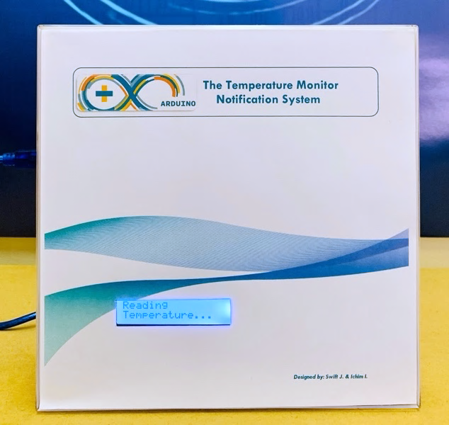

Figure 25 The Inside open- view of Arduino (TMNS) [35]

Figure 24 The front view of Arduino (TMNS) [36]

After integration inside the box, the (TMNS) has been continuously tested in 3 different modes:

1. **Normal Operation Mode** – during this mode the system continuously checking the temperature inside a house, if a user wish, by pressing Grove Button on the left side of the box, the ambient temperature is displayed on Grove - LCD RGB Backlight Display;
2. **The Fire Alarm Mode –** this mode is activated, if the temperature is higher than 57C degrees, the TMNS will Display on Grove - LCD RGB Backlight Display the Alert Message *“Fire Hazard”* see Fig.16, flashing from white-to-red colours and the Buzzer will trigger an Alarm Sound, and the connection to (IFTT) Cloud will start immediately, and a notification is sending to a designated person, via email or SMS;
3. **The Low Temperature Mode** - this mode is activated if the average temperature is lower than 20C (68F) the (TMNS) connects to the Cloud (IFTT) Cloud and notification is sent to a designated person. And the person receiving the message, regarding the drop of the temperature in the house, has an option to use Blynk App, in order to connect remotely the oil heater, see Fig.15.

## SUMMARY

During developing and implementation of the Temperature Monitor and Notification System, three main issues arose , first and most important is the implementation of temperature monitoring hasn’t been implemented only on one board, ESP32, due to errors while sampling the temperatures in the second loop, but by adding second board, Arduino UNO and Grove Base Shield V2.

Second issue has been related to connection to (IFTT) Cloud service, which has been fixed, by introducing the full host name and trigger, in “http GET” request sent to the cloud. And third problem, with Blynk service connection to ESP32, has been solved, by choosing the right Arduino board, in Arduino IDE.

After a number of testing in all 3 modes described above, the (TMNS) is working without any problems, the notifications have been received both via email or/and SMS, the temperature reading is with an accuracy of 1.5°C and the goal of the project has been met.

Furthermore, the total cost of the project has been elaborated and calculated, see “Table of Equipment and Prices” see Fig.29, Appendix D) where each Arduino equipment is described and total cost of project is just 46.93 euros, which is more affordable then other (IoT) technologies that are quite expensive for wide use.

## 

## IDEAS FOR FUTURE REPLICATION AND/OR RESEARCH THE PROJECT TOPIC

Taking into consideration, the (TMNS) hasn’t been implemented just using a single Arduino board (ex: ESP32) due to the errors described in the “Troubleshooting” chapter see p.13 for future replication and improvement of the project the first goal is to implement the (TMNS) using a single board, achieving a reduced cost, minimizing the hardware and size of the system.

Further enhancements to the system can be made by adding more sensors, such as: Smoke and CO detectors that will provide a improve versatility and utility to the system. In order to add resilience to (TMNS), the notification process can be enhanced using both (IFTT) and Blynk Cloud services. Further automation can be achieved by using the system to order fuel directly from a local fuel oil or coalprovider, this would require an account having been set up previously.

## CONCLUSION

This report has shown that as cold weather persists in Ireland and while people affected by fuel poverty, a solution similar to the Arduino Temperature Monitor and Notification System(TMNS) may become a necessity. While a number of different (IoT) notification systems are in competition with each other, the solution proposed here appears to have excellent potential for those affected by fuel poverty and for the peace of mind of their friends and family.

The (TMNS) working in three different modes, the normal operation mode, the fire alarm mode and the low temperature mode. All three modes have distinct advantages over other (IoT) methods of notification. Because (TMNS) operate even if in the house is not a broadband, the price for implementing is greatly reduced, using just an smartphone (Android/IOS) with hotspot on. The implementation of Arduino based notification system also allow the use of other Arduino sensors(Smoke or CO detectors) to provide a better versatility to the system.

In terms of notifications to a relative/care worker, as this report has shown, requires a stable method of connection with the Cloud Services. Therefore, redundancy implementation by pairing the Arduino board with (IFTT) and Blynk Service may be a necessity. Obviously finding a solution to fuel poverty with just with (IoT) would be impossible but may enable the relatives or carers to act quick enough to come and help those people affected by fuel poverty and that early intervention is critical in minimising negative health outcomes and associated costs.

# REFERENCES

|  |  |
| --- | --- |
| [1] | Kenny, “Addressing Loneliness and Social Isolation Sharing the Experience,” 11 2015. [Online]. Available: https://www.respond.ie/wp-content/uploads/2015/10/Respond-Booklet-Research-Summary.pdf. [Accessed 4 02 2020]. |
| [2] | H. McAvoy, “The Institute of Public Health in Ireland,” 12 2007. [Online]. Available: https://www.lenus.ie/bitstream/handle/10147/45784/9138.pdf?sequence=1&isAllowed=y. [Accessed 4 02 2020]. |
| [3] | M. Lane, “BBC,” 2011. [Online]. Available: https://www.bbc.com/news/magazine-12606943. [Accessed 4 02 2020]. |
| [4] | Holland, “Irish Times,” 2019. [Online]. Available: https://www.irishtimes.com/news/social-affairs/poverty-in-ireland-over-140-000-children-in-cold-damp-homes-1.4110042. [Accessed 4 02 2020]. |
| [5] | C. S. O. CSO, “Social Justice,” 2019. [Online]. Available: https://www.socialjustice.ie/content/policy-issues/almost-400000-people-experience-fuel-deprivation-while-ireland-among-top-5. [Accessed 04 02 2020]. |
| [6] | I. Ichim, *The Diagram of Initial Proposal,* Dublin, 12/02/2020. |
| [7] | Pololu, 2020. [Online]. Available: https://www.pololu.com/product/2191. [Accessed 11 02 2020]. |
| [8] | Seedstudio, 2020. [Online]. Available: https://www.seeedstudio.com/Base-Shield-V2.html. [Accessed 11 02 2020]. |
| [9] | S. Studio, 2020. [Online]. Available: https://www.seeedstudio.com/GeeekNET-ESP32-Development-Board-p-2945.html. [Accessed 11 02 2020]. |
| [10] | SeedStudio, 2020. [Online]. Available: https://www.seeedstudio.com/Grove-LCD-RGB-Backlight.html. [Accessed 11 02 2020]. |
| [11] | S.-. Temp, 2020. [Online]. Available: https://www.seeedstudio.com/Grove-Temperature-Sensor.html. [Accessed 11 02 2020]. |
| [12] | S. Studio-Relay, 2020. [Online]. Available: https://www.seeedstudio.com/Grove-Relay.html. [Accessed 11 02 2020]. |
| [13] | I. Electronics, 2019. [Online]. Available: https://irishelectronics.ie/SRD-05VDC-SL-C-DC-5V-Relay. [Accessed 11 02 2020]. |
| [14] | S. S. -Buzzer, 2019. [Online]. Available: http://wiki.seeedstudio.com/Grove-Buzzer/. [Accessed 11 02 2020]. |
| [15] | S. -. Touch, 2020. [Online]. Available: http://wiki.seeedstudio.com/Grove-Touch_Sensor/. [Accessed 11 02 2020]. |
| [16] | Ammazon, 2019. [Online]. Available: https://www.amazon.co.uk/BENSN-Universal-Adapter-Selectable-Nextbook/dp/B082SWL6HH/ref=sr_1_13?adgrpid=56886444165&gclid=CjwKCAiAvonyBRB7EiwAadauqZziWDAnYd9MmTu2JSobjbW8RK6ldHmqfY_rigiOjo1udcHzsd3GcRoCBecQAvD_BwE&hvadid=291305828538&hvdev=c&hvlocphy=10078. [Accessed 11 02 2020]. |
| [17] | IFTT, “web.archive.org,” [Online]. Available: https://web.archive.org/web/20141015215100/https://ifttt.com/wtf. [Accessed 9 2 2020]. |
| [18] | Webhooks, “IFTT,” 2019. [Online]. Available: https://ifttt.com/maker_webhooks. [Accessed 9 2 2020]. |
| [19] | R. I, 2018. [Online]. Available: https://roboindia.com/tutorials/blynk-introduction-nodemcu/. [Accessed 9 02 2020]. |
| [20] | Devleco, 2019. [Online]. Available: https://www.develcoproducts.com/products/sensors-and-alarms/heat-alarm/. [Accessed 18 02 2020]. |
| [21] | I. I. &. J. Swift, *The Fire Allert sample message,* Dublin, 2020. |
| [22] | Newair, “newair.com,” 2018. [Online]. Available: https://www.newair.com/blogs/learn/ceramic-vs-oil-filled-heater. [Accessed 9 02 2020]. |
| [23] | I. I. &. J. Swift, *The Temperature Monitor & Notification Sytem,* Dublin, 2020. |
| [24] | J. S. &. I. Ichim, *The Block Diagram of TMNS,* Dublin, 2020. |
| [25] | M. Link, 2019. [Online]. Available: https://www.megunolink.com/articles/wireless/how-do-i-connect-to-a-wireless-network-with-the-esp32/. [Accessed 19 02 2020]. |
| [26] | M. Lab, 2019. [Online]. Available: https://microcontrollerslab.com/lm35-temperature-sensor-with-esp32-web-server/. [Accessed 19 02 2020]. |
| [27] | J. S. &. I. Ichim, *The main Flow Chart,* Dublin, 02/2020. |
| [28] | J. S. &. I. Ichim, *The SMS routine flowchart,* Dublin, 02/2020. |
| [29] | J. S. &. I. Ichim, *The Blynk Routine,* Dublin, 02/2020. |
| [30] | IFTT, January 2020. [Online]. Available: https://ifttt.com/applets/324799p-if-url-request-then-send-an-sms-to-value1-with-message-value2. [Accessed 9 02 2020]. |
| [31] | J. S. a. I. Ichim, *Setting up an applet using Webhooks Services,* Dublin, 2020. |
| [32] | I. Ichim, *The Printscreen of Blynk APP, button set up as switch,* Dublin, 2020. |
| [33] | I. Ichim, *Fuel Poverty diagram,* Dublin, 02/2020. |
| [34] | J. S. a. I. Ichim, *The error of temperature reading of LM35,* Dublin, 11/2020. |
| [35] | I. I. &. J. Swift, *The photo of inside view of TMNS,* Dublin, 2020. |
| [36] | I. I. &. J. Swift, *The front view of TMNS,* Dublin, 2020. |

# APPENDICES

# The Main Flowchart of TMNS Appendix A

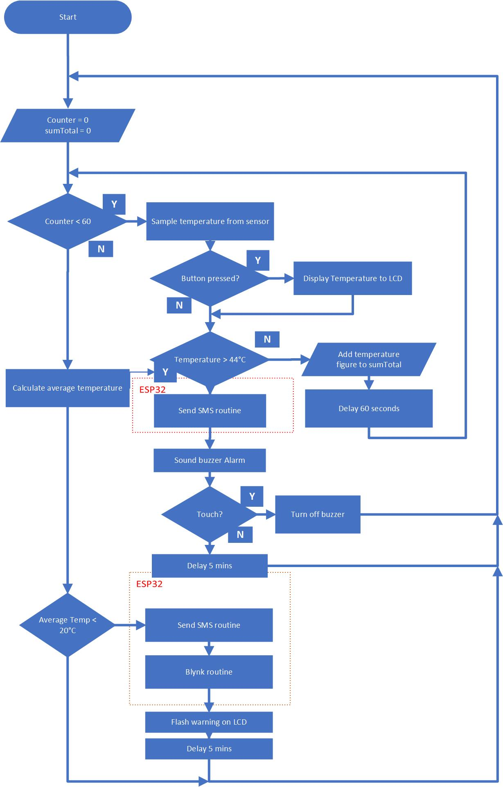

Figure 26 The Main Flowchart of TMNS [27]

# The SMS Routine Appendix B

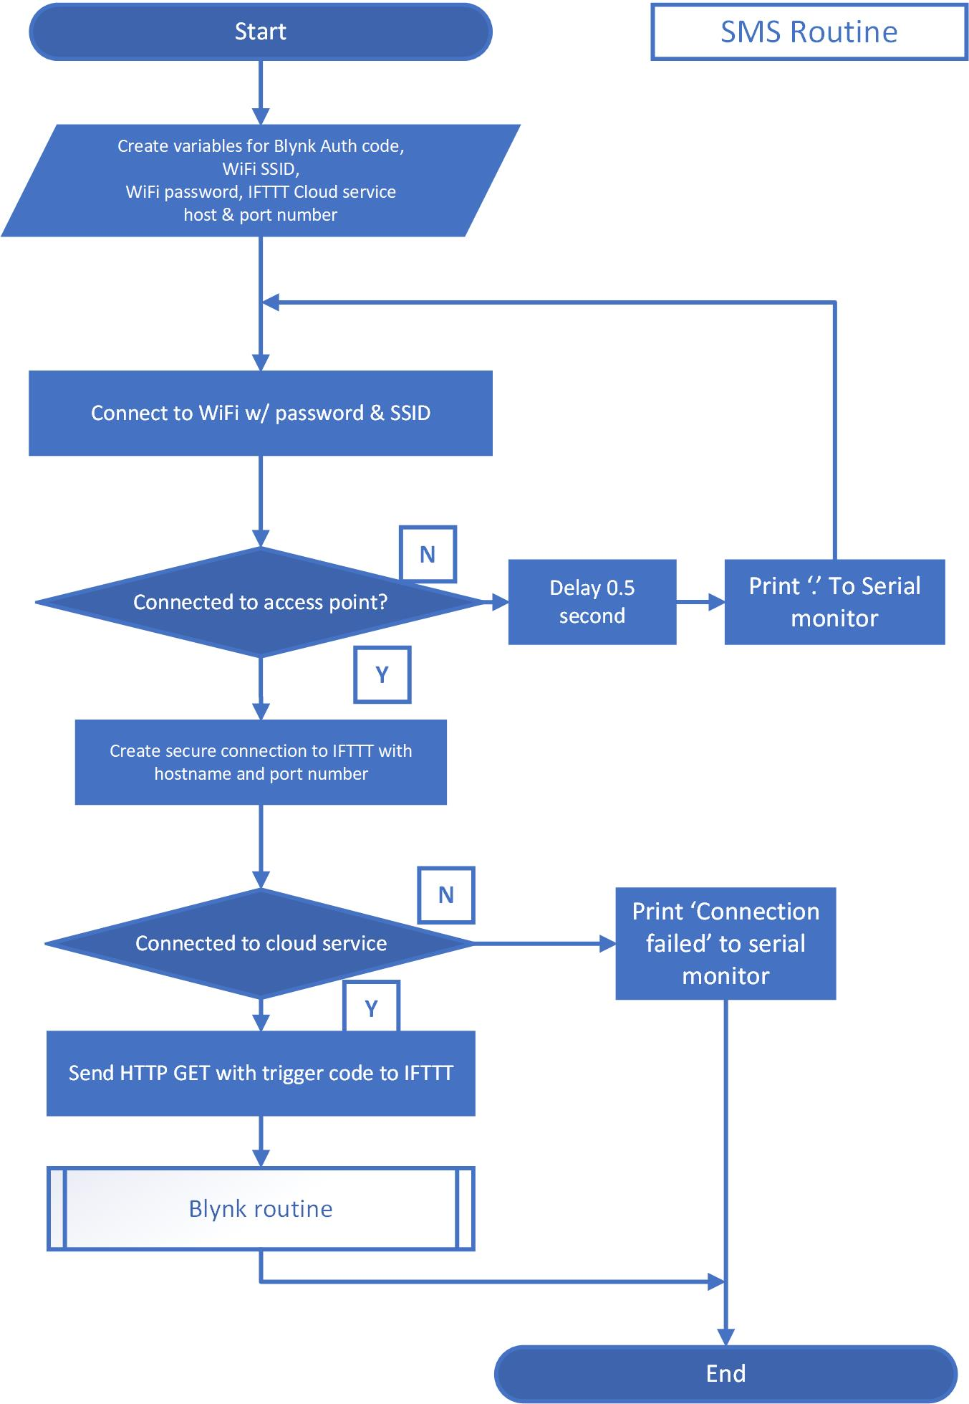

Figure 27 The SMS routine flowchart of TMNS [28]

# 

# The Blynk Routine Appendix C

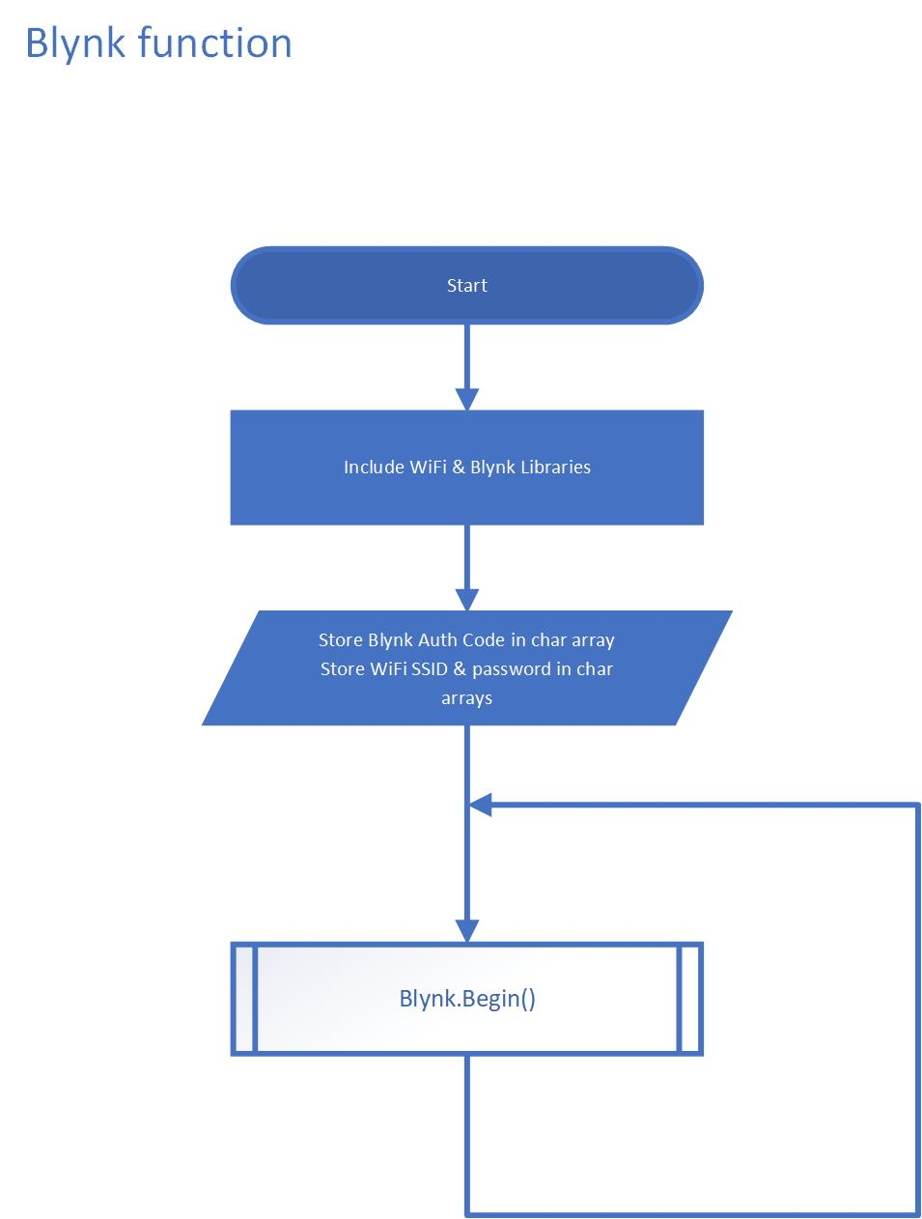

Figure 28 The Blynk Service flowchart [29]

# 

# 

# 

# The Table of Equipment and Prices Appendix D

**Figure 29 The Table of Equipment and Prices**

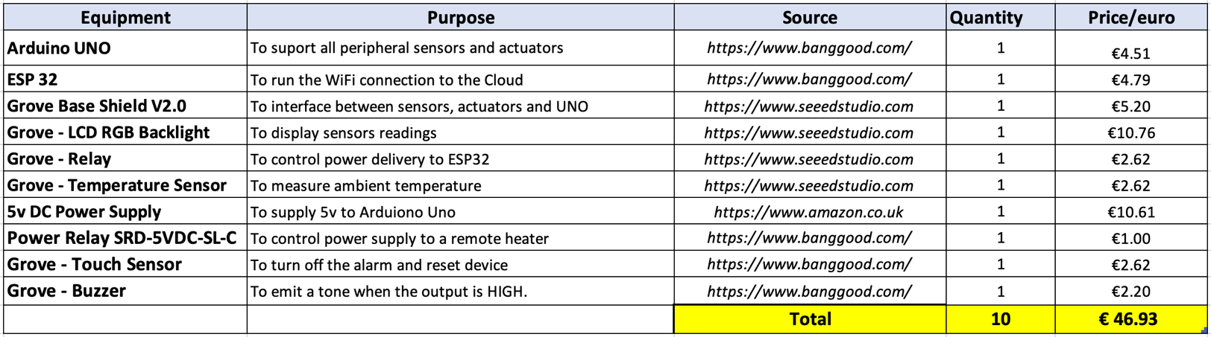

# The code on Arduino UNO Appendix E

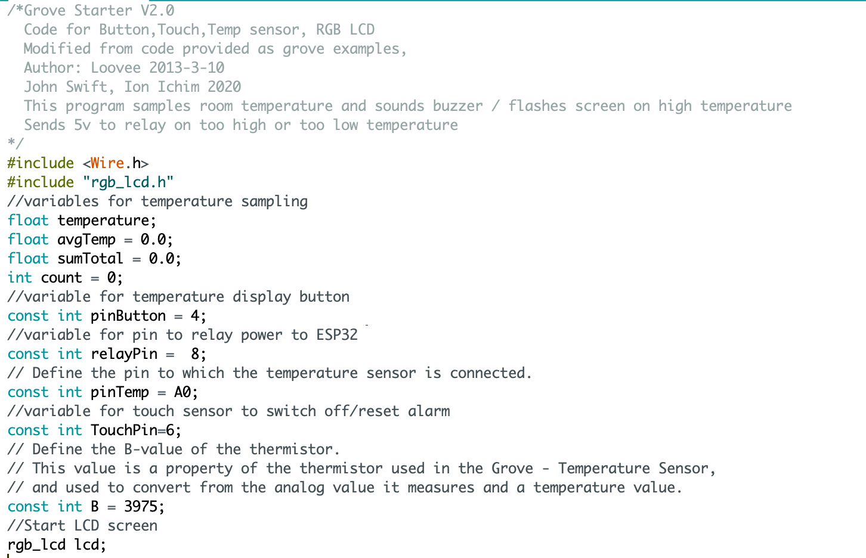

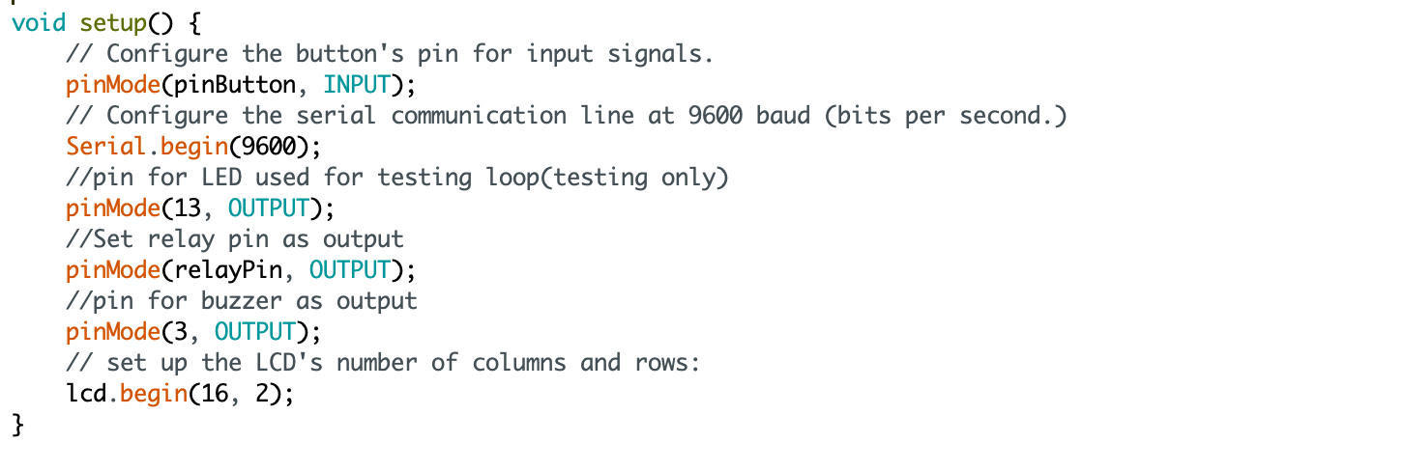

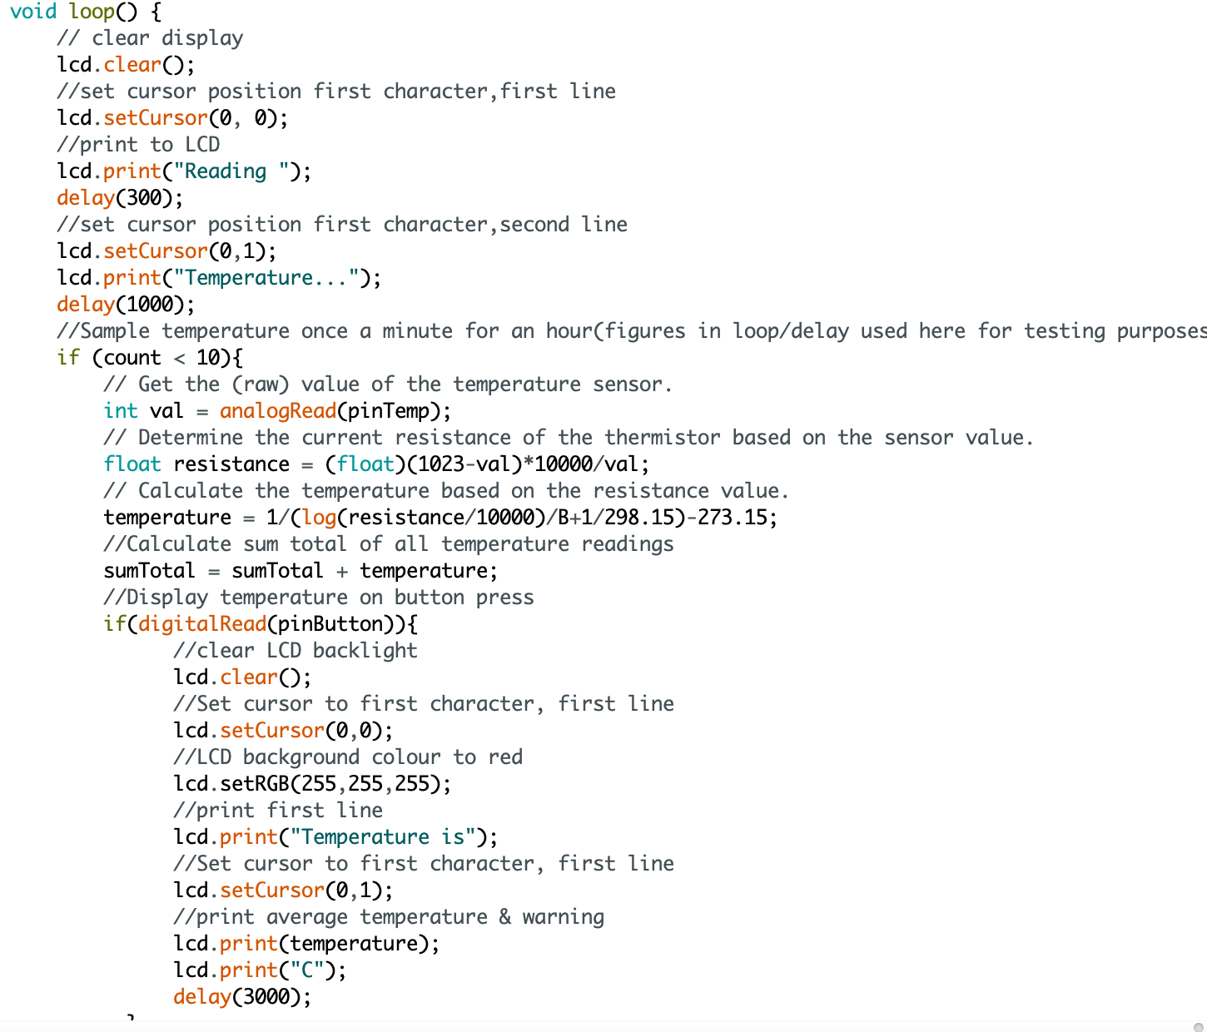

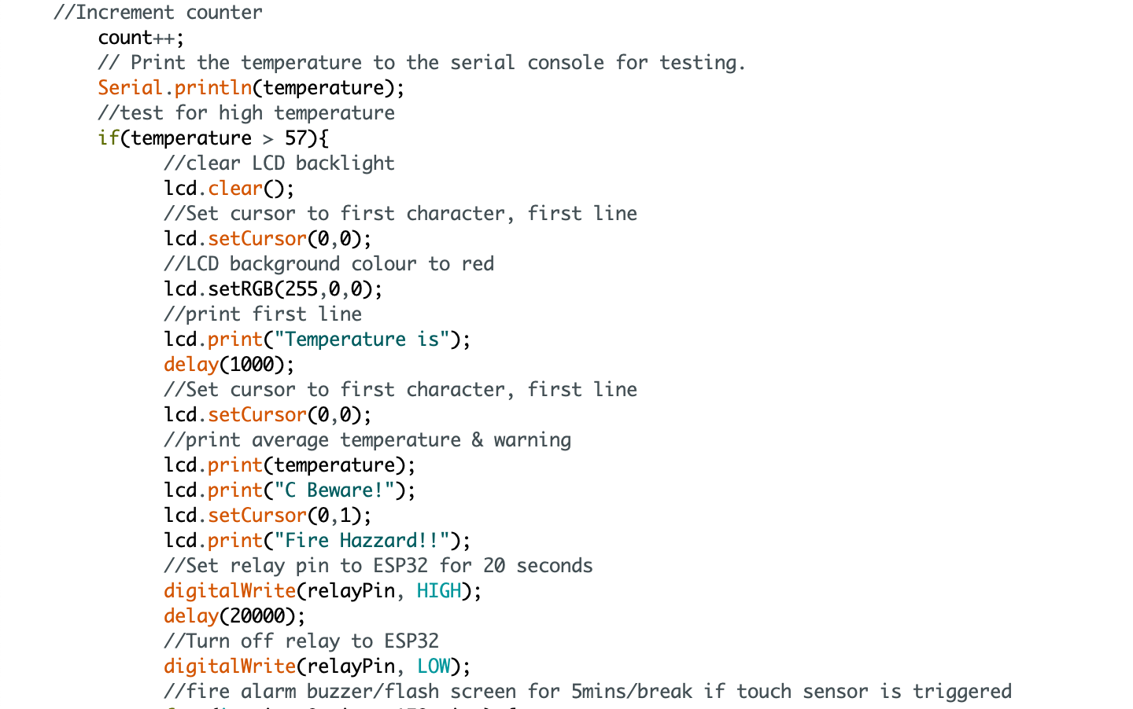

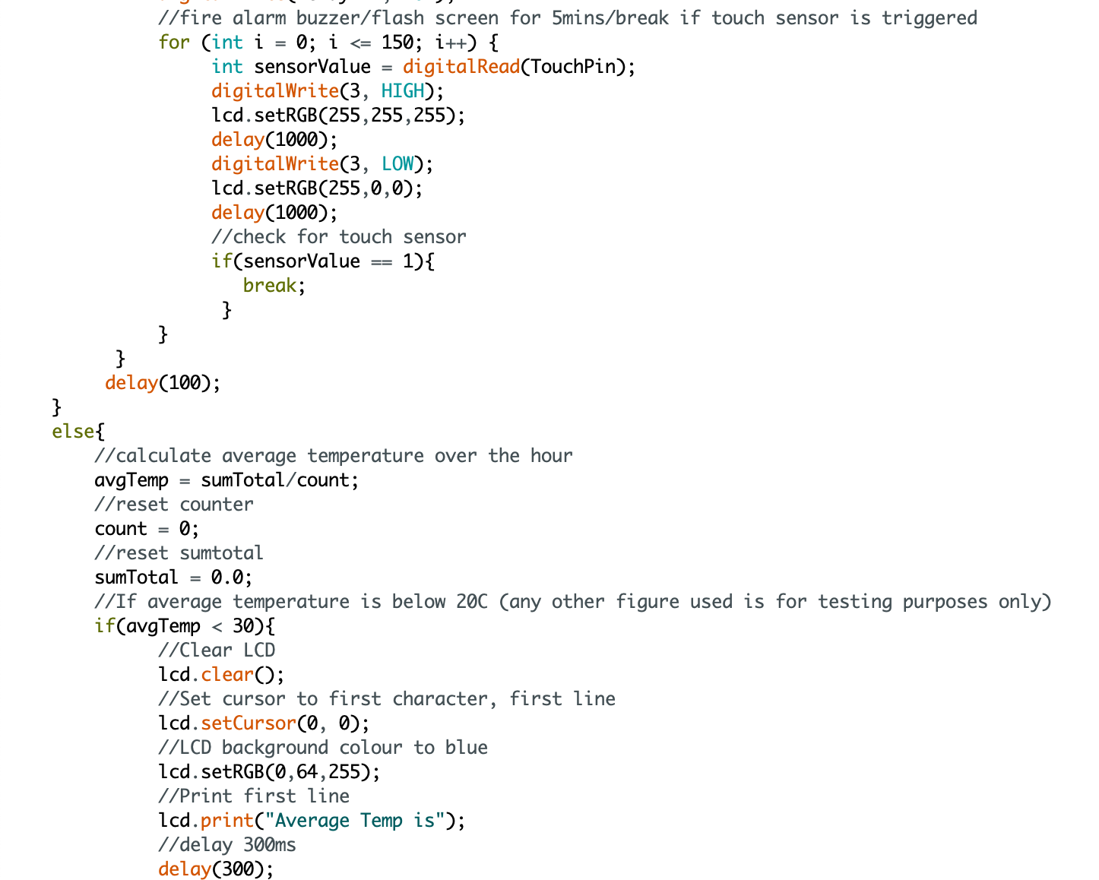

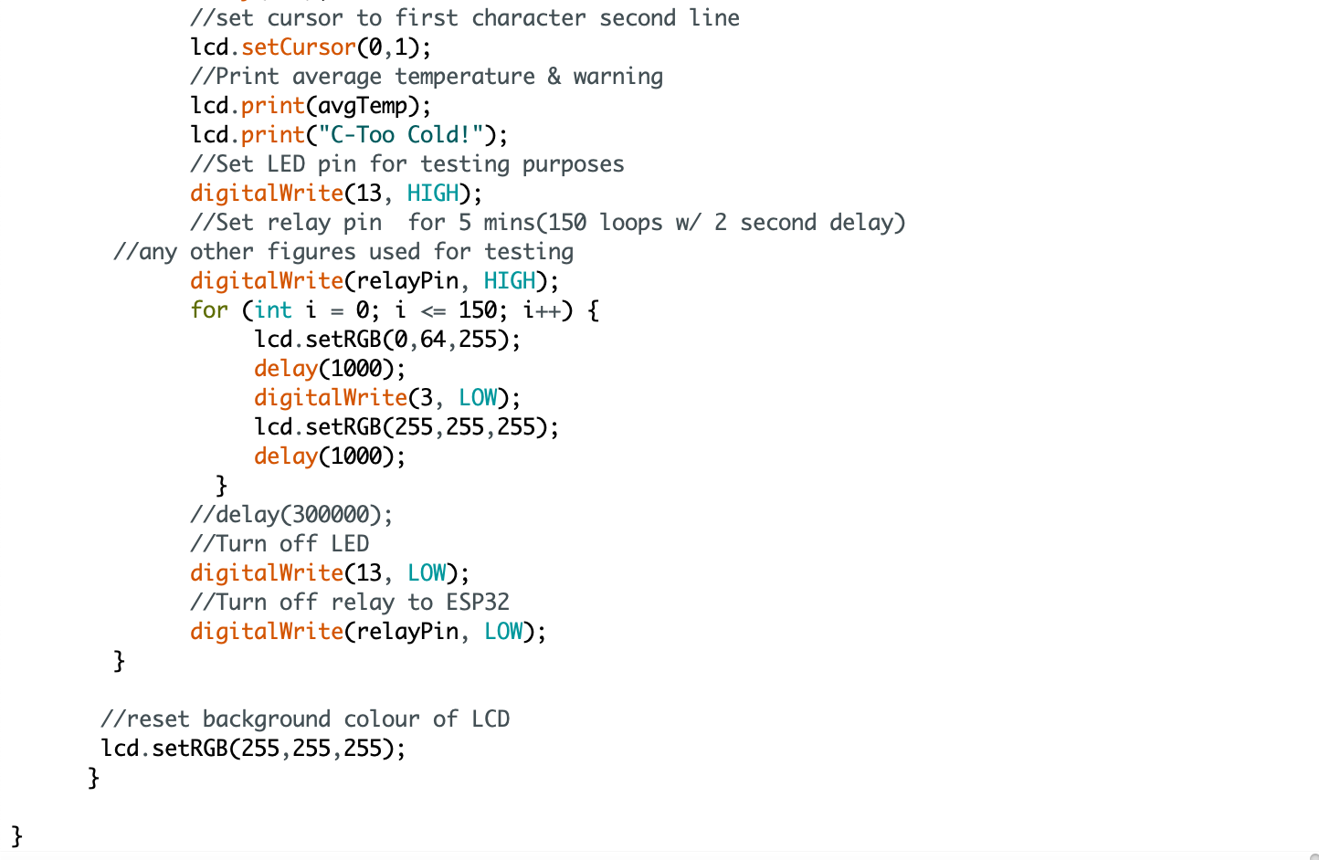

# The code on Arduino ESP32 Appendix F

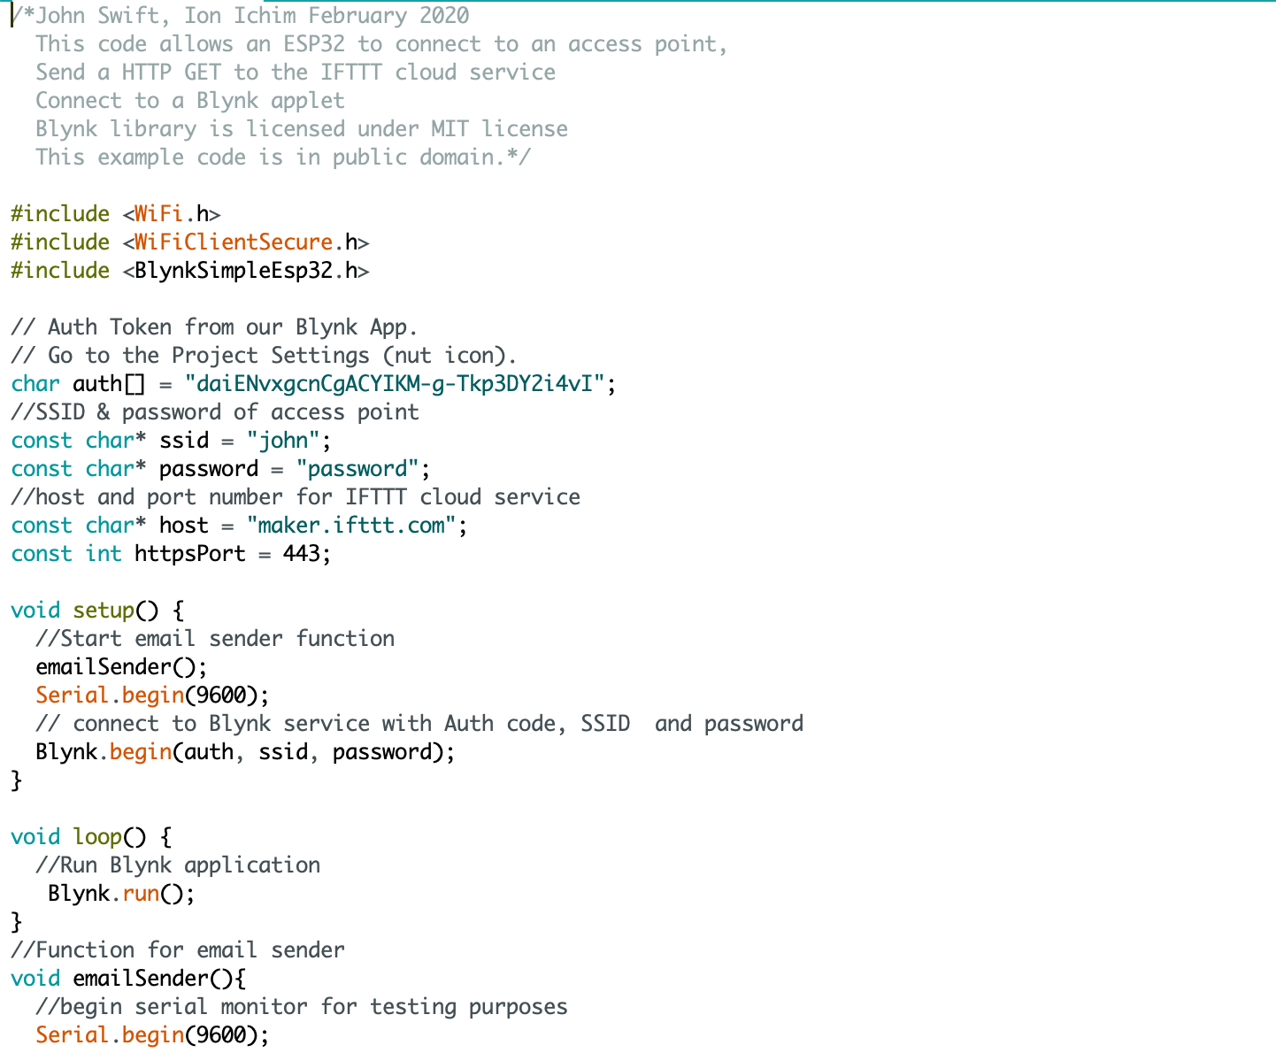

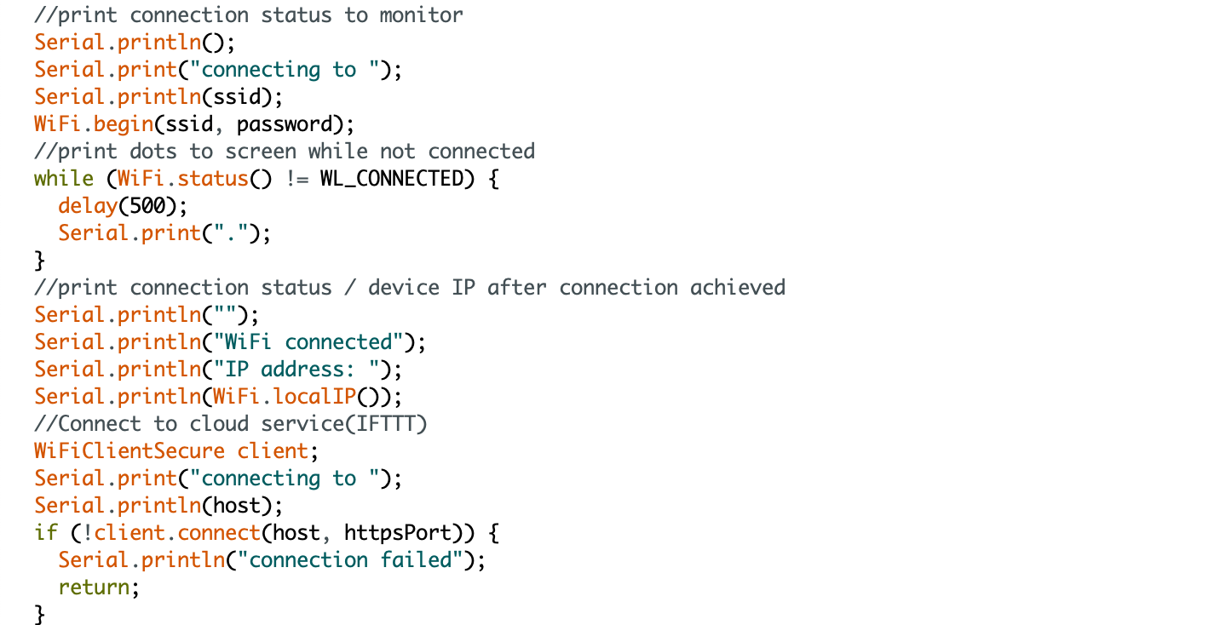

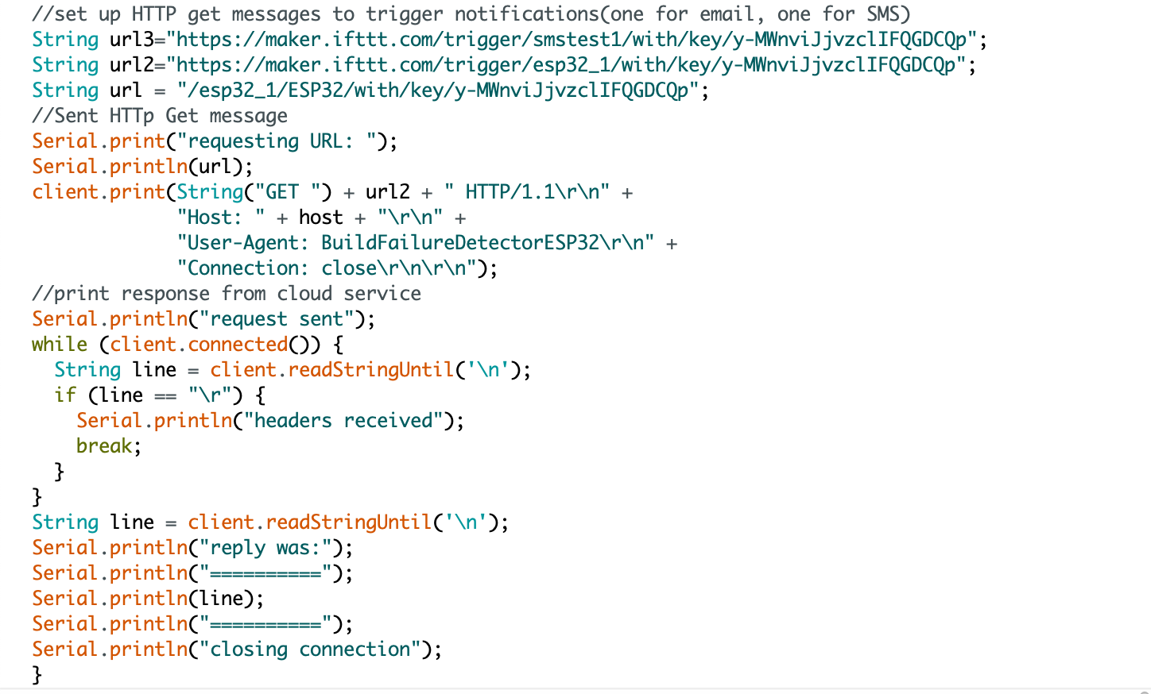

End of code